**Name:** Phạm Gia Phúc **Student ID:** ITCSIU22178

**Web Application Development Laboratory**

**Lab 1 – Introduction**

**Exercise 1:** HTML and CSS images  
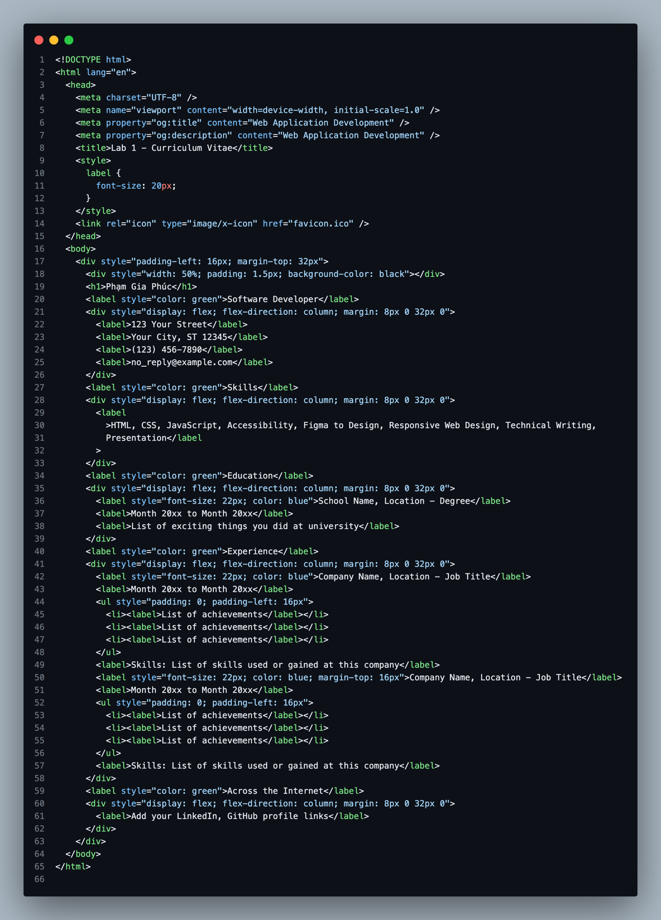

* Output:

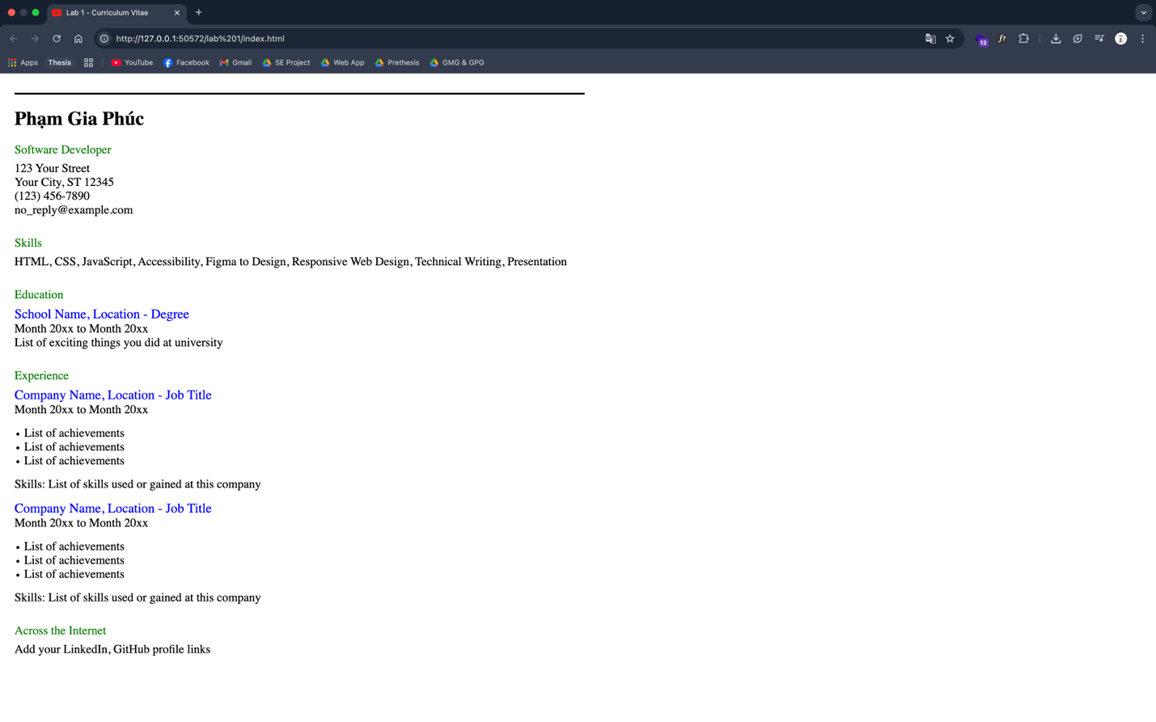

**Exercise 2:** MySQL scripts

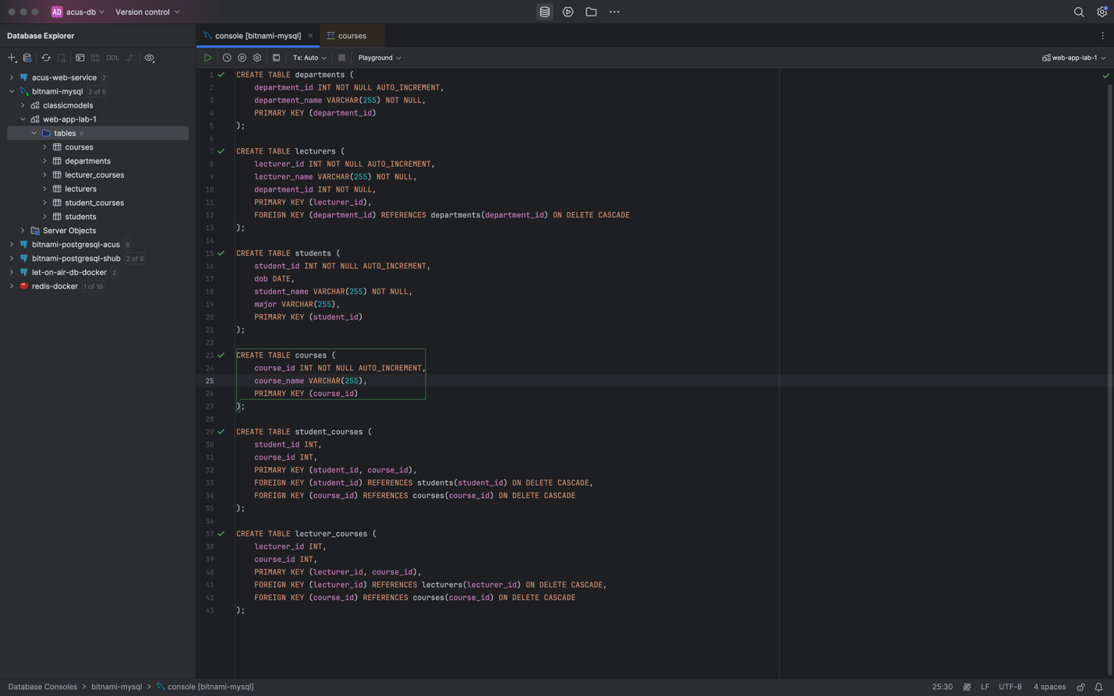

* Database diagram:

